New zealand customs service – ses team
50 Anzac Avenue, Auckland, New Zealand
PO Box 29, Shortland Street, Auckland 1140
Phone: 09 927 8114
Email: ses@customs.govt.nz, Website: www.customs.govt.nz
25 June 2014

Kevin Tansey
SafePak
PO Box 46018
Herne Bay
Auckland 1147

Dear Kevin
Re: NZ Customs-approved security seal meeting the ISO 17712:2013 standard
Thank you for your email to Senior Customs Officer Phil Riini dated 06 June 2014 in which you provided evidence confirming that the Unisto Hi-Genius bolt seal meets the new ISO 17712:2013 standard for high security seals.
I therefore confirm that the Unisto Hi-Genius bolt seal continues to meet the minimum requirements for a New Zealand Customs-approved seal and is approved for use by partners in the New Zealand Customs Secure Exports Scheme.

Yours sincerely
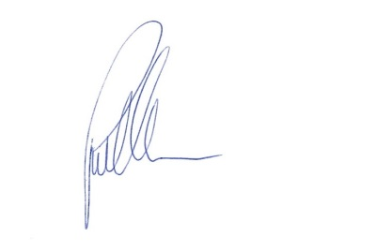
Paul Williams
Chief Customs Officer, Service Delivery
Border Operations

